Mark Lobdell

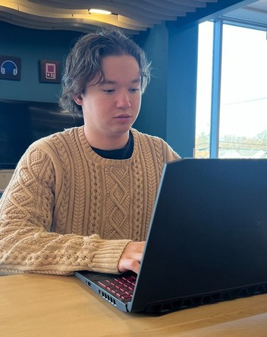

[markplobdell.com](http://markplobdell.com/) [markplobdell@gmail.com](mailto:markplobdell@gmail.com) (331)-205-0761

[LinkedIn](https://www.linkedin.com/in/mark-lobdell-5b2343300/) [GitHub](https://github.com/markplobdell)

Sherman, TX

Soft Skills

Time Management Organization Open to Criticism Teamwork Attention to Detail

Work Experience

Amazon Delivery Associate

GTB Logistics | Summer 2024

Tennis Instructor

Elmhurst PD | 2021-2024

Panera Bread | 2019

Computer Programmer For Hire

Experience

 Built and deployed own personal website using GitHub static pages

 SQL Database Management: Designed and built MySLQ database for voter registration program using Java and JavaFX

 Networking Principles Simulation: Built a Slack program clone using TCPIP protocols through Java.

 6 Years Experience using Google and Microsoft Office Suite

 Management Team Supervision and Coordination

Hard Skills

PROGRAMMING LANGUAGES:

 Java (5 years)

 C++, Python, HTML/CSS, JavaScript (3 years)  SQL (1 year)

TECHNOLOGIES & TOOLS:

APIs, JSON, Advanced Data Structures, Networking Principles,

Search Algorithms, Object-Oriented Programming SOFTWARE:

Microsoft Office Suite, Google Workspace

Educational History Austin College | 2022-2024

Bachelor’s Degree in Computer Science

3.48 GPA

 Continued education in computer science  Participated in tennis full time

College of DuPage | 2019-2022

Associate’s Degree in Science

 87 total credit hours

 Majored in computer science

 Transferred to Austin College with a 3.0 GPA  Participated in tennis during duration